Mobile Quiz Android Project

Overview:

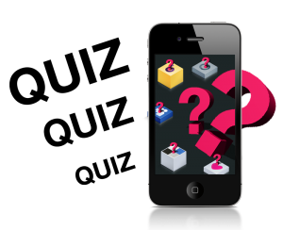
In our application there is an Admin, who is sitting and handling all the questions on the server will update regular questions on the server and users, as a client they will get latest quizzes in their apps regularly.

Proposed System:

The user will register his or her name to play the quiz game. He/she will have to provide other information as required. Then they will get options on which topic or subject they want to play the quiz game. According to their choices they question will appear. User can move forward by giving the correct answers. If they give wrong answer the correct answer will be showed and move to the next question. When the desired amount of questions are finished then the user will get his or her total score. There will be a fixed time to answer any question. If anyone can’t give the right answer within time it will be accepted as a wrong answer.

Mobile Quiz Modules:

Given are the modules for mobile quiz through project system:

1.) Admin Module: All the quizzes update, news update and all the relevant communication with the user is done by admin module. Admin module is the main module which manages all other module as well in the given system. All the actions are mainly handled by the admin only.

2.) Player Module: Players can make their account in this module and can play quizzes and score the game in this module. This module will be designed for the player’s easiness.

3.) Quiz Database Module: All the questions, answers, new and old quizzes and other relevant details related to quizzes are maintained in this module.

4.) Score Module: Scores of all the quizzes of all the users are maintained in this module and ranking are being also displayed in this module.

Software Requirements:
- Android software development kit (SDK)
- Windows XP
- Java Development Kit (JDK)
- Notepad
- Android Studio

Hardware Requirements
- Hard Disk – 2 GB.
- RAM – 1 GB.
- Processor – Dual Core or Above.
- Mouse.
- Keyboard.
- Monitor.

